TWIN RIVERS PARISH COUNCIL

THE ORDINARY MEETING OF THE COUNCIL WILL BE HELD
IN THE VILLAGE HALL ON TUESDAY 11th March 2025

You are summoned to attend.
Public Forum 7.30-7. 40pm.Any members of the public attending the meeting may be given (at the chairman’s discretion) a combined 10-minute time slot to address councillors on any items of concern or interest. After this period the public are welcome to stay for the full parish council meeting but CANNOT speak nor offer advice/opinion on any matter. This public participation is NOT part of the parish council meeting and as such there are no rights to record this part of the meeting in any way.

AGENDA

Apologies for absence.

Minutes

The minutes of the last meeting held on 11th February 2025 have been circulated to all councillors prior to the meeting.

Declarations of Interest.

Declaration of Interest – The parish councils (Model Code of Conduct Order 2011). To record any declarations of interest by any member in respect of items on this agenda). Members declaring interests should identify the agenda item and type of interest being declared.
Financial Matters

Current account - £

Cow lane Current account -

Business reserve £

Cheques
Clerks wages
Spec farm solutions £1056.00
Goole times- £112.80
Microsoft- £84.99

ONGOING ISSUES

Ousefleet Community Hall update.

Health and Safety Issues.

Cow Lane

PLANNING White House Piggeries Narrow Lane Ousefleet East Riding Of Yorkshire DN14 8HW: Change of use of outbuildings to wedding and events venue comprising ceremony barn, function barn with catering kitchen and storage block, erection of entrance porch to function barn and pergola, installation of new wall cladding and doors and creation of additional vehicular access, erection of 2m high boundary fence to separate venue from the dwelling 'White House' and associated landscaping and car parking following partial demolition of existing piggery building (Resubmission of 24/01022/PLF)
COUNCILLOR ISSUES
War Memorial

Whitgift lighthouse

Speeding

GDPR

Ousefleet Defibrillator

National Grid

Carbon capture pipeline

Police grant

Stamps

Penfold

Newsletter

V E-Day Grant

Noticeboard

Ousefleet and Adlingfleet defibs

Planters

Emergency plan

Resignation

Phone Box

Sim card payments

Insurance

CORRESPONDENCE

WARD COUNCILLOR’S REPORTS

ITEMS FOR THE NEXT AGENDA

Date and place of the next meeting

8th April 2025. 7:30pm Ousefleet village hall

Signed

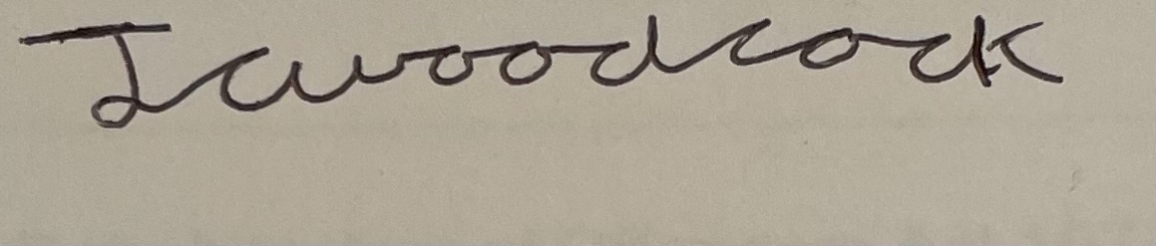
James Woodcock- Clerk and RFO

